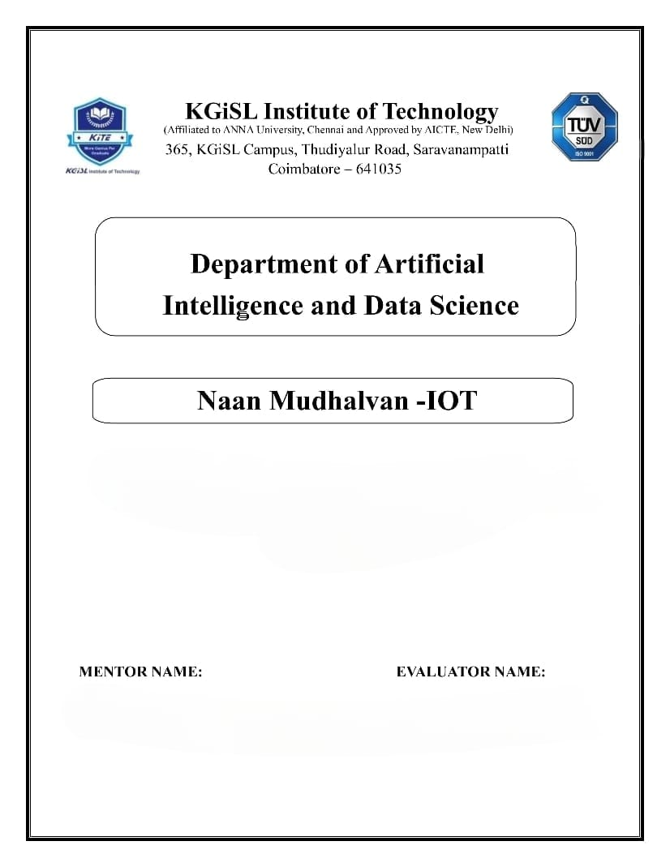

**PROBLEM STATEMENT : AIR QUALITY MONITORING SYSTEM**

Mr.MOHANKUMAR.M

Ms.AKILANDESWARI.M

**Problem Statement:**

We’re addressing the issue of a lack of accessible real-time air quality data in our region. People currently lack knowledge about the air they breathe, which may negatively impact their health and quality of life. A system that can continuously check the air quality and provide the public with this essential data is required.

**Solution:**

Our solution aims to provide the public with easy access to vital air quality information, ultimately raising awareness about air quality impact on health and well-being. By offering real-time data and health recommendations, we empower individuals and communities to make informed decisions to protect their health and the environment.

**Objectives:**

The project aims to address the absence of accessible real-time air quality information, enhancing public awareness of its impact on health. Through IoT devices measuring key pollutants and weather parameters, the system will provide continuous, user-friendly data on PM2.5, PM10, NO2, CO, O3, SO2, temperature, humidity, and wind. The platform will empower individuals and communities with easily comprehensible real-time charts and maps, enabling informed decisions to safeguard health and the environment. Ultimately, the objective is to create a reliable and accessible source of air quality data, promoting healthier living and environmental consciousness within the community.

**IoT device setup:**

1. Identify and select sensors for air quality parameters, along with a microcontroller (e.g., Arduino, Raspberry Pi) for sensor interfacing.

2. Connect chosen sensors to the microcontroller using specified pins and develop code for data retrieval.

3. Choose a communication protocol (e.g., Wi-Fi, GSM, LoRa) and establish connectivity between the microcontroller and a central server or cloud platform.

4. Develop a protocol for real-time transmission of sensor data to the selected cloud platform.

5. Select a cloud platform (e.g., AWS IoT, Azure IoT, Google Cloud IoT), create an account, and set up a project.

6. Define a database structure for secure and reliable storage of sensor data.

7. Create a user-friendly web platform using a chosen framework (e.g., React, Angular, Vue.js) and design a dashboard for real-time data visualization.

8. Establish a connection between the cloud platform and the web platform, enabling real-time data retrieval and display.

9. Implement secure user authentication mechanisms for accessing the web platform.

10. Set up alert systems for abnormal air quality levels and implement notifications (e.g., email, push) to inform users.

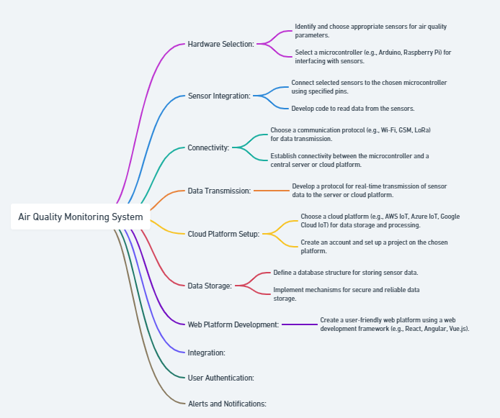

**Platform development:**

1. Define key features and functionalities for the air quality monitoring platform.

2. Choose a suitable web development framework (e.g., React, Angular, Vue.js) based on project needs.

3. Design and implement an intuitive and accessible user interface (UI) for the platform.

4. Develop backend logic for data processing, storage, and communication with the cloud platform.

5. Choose and set up an appropriate database (e.g., MySQL, MongoDB) for secure sensor data storage.

6. Implement secure user authentication mechanisms to control platform access.

7. Integrate real-time air quality data visualization using charts and maps on the frontend.

8. Incorporate alert systems for notifying users of abnormal air quality levels through email or push notifications.

9. Ensure a responsive design for seamless user experience across different devices.

10. Conduct thorough testing to identify and rectify any bugs or issues in the platform.

11. Collect user feedback and iteratively improve the platform's usability and performance.

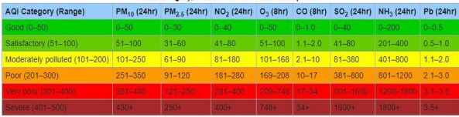

**Project Requirements:**

A. Arduino Uno 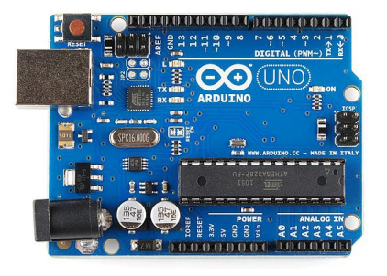

B. Wi-Fi module ESP8266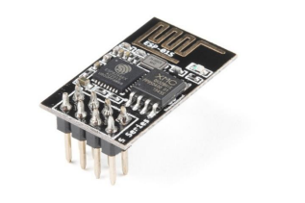

C. 16x2 LCD

D. MQ135 Gas sensor 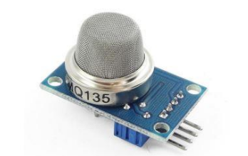

E. MQ 7 LPG gas sensor 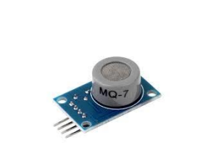

F. Buzzer

**Circuit diagram:**

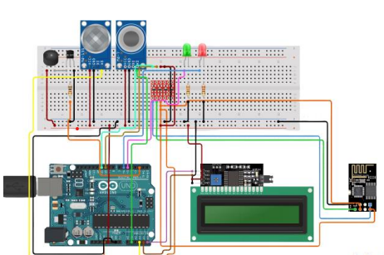

**Code implementation:**

[**https://github.com/Lithikhaa/Naanmudhalvan_IOT**](https://github.com/Lithikhaa/Naanmudhalvan_IOT)

# sensor_reading.py

import random

import time

def read_sensor_data():

# Simulate reading data from sensors

pm25 = random.uniform(1, 50)

pm10 = random.uniform(1, 50)

no2 = random.uniform(1, 20)

co = random.uniform(1, 10)

o3 = random.uniform(1, 30)

so2 = random.uniform(1, 15)

data = {

'pm25': pm25,

'pm10': pm10,

'no2': no2,

'co': co,

'o3': o3,

'so2': so2,

}

return data

while True:

sensor_data = read_sensor_data()

print("Sensor Data:", sensor_data)

time.sleep(5)

# data_transmission.py

import paho.mqtt.client as mqtt

import json

import time

def transmit_to_cloud(data):

client = mqtt.Client()

client.connect("your-aws-iot-endpoint", 8883)

payload = json.dumps(data)

client.publish("sensor-data-topic", payload)

client.disconnect()

while True:

sensor_data = read_sensor_data()

print("Sensor Data:", sensor_data)

# Transmit data to the cloud

transmit_to_cloud(sensor_data)

time.sleep(5)

// AirQualityDashboard.js

import React, { useState, useEffect } from 'react';

const AirQualityDashboard = () => {

const [airQualityData, setAirQualityData] = useState({});

useEffect(() => {

// Fetch real-time data from the server

const fetchData = async () => {

const response = await fetch('http://your-server/api/air-quality');

const data = await response.json();

setAirQualityData(data);

};

fetchData();

}, []);

return (

<div>

<h1>Air Quality Dashboard</h1>

<p>PM2.5: {airQualityData.pm25}</p>

<p>PM10: {airQualityData.pm10}</p>

<p>NO2: {airQualityData.no2}</p>

<p>CO: {airQualityData.co}</p>

<p>O3: {airQualityData.o3}</p>

<p>SO2: {airQualityData.so2}</p>

</div>

);

};

export default AirQualityDashboard;

**air quality monitoring system can raise public awareness about air quality and health impacts:**

1. Provides real-time, accurate information on current air quality to the public.

2. Communicates health risks associated with air pollutants, fostering awareness.

3. Empowers individuals to make informed decisions based on current air quality conditions.

4. Encourages community engagement in air quality monitoring and information sharing.

5. Raises awareness about the environmental impact of air pollution.

6. Equips the public with data to advocate for policies addressing air pollution.

7. Assists vulnerable populations in taking precautions during poor air quality periods.

8. Serves as an educational tool in schools, enhancing understanding of air quality's impact.

9. Promotes behavioral changes to collectively improve air quality.

10. Aids in emergency preparedness for air quality-related events like wildfires or accidents.

Result:

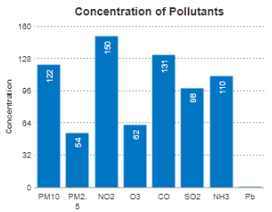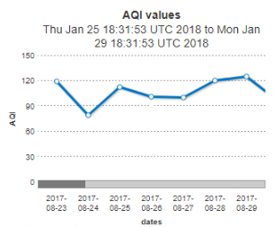

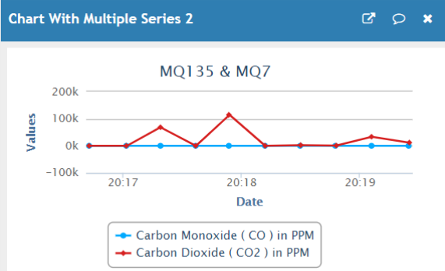

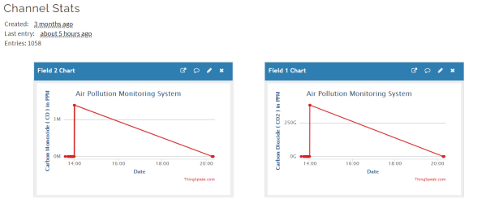

Output:

